Keeping what you say Private
When you talk to us we will not tell other people what you have said we will keep it private.
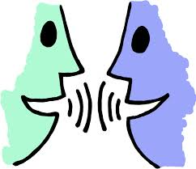
Sometimes we may think it’s a good idea to talk to other people about what you tell us, like Tutors, Doctors or Social Workers.
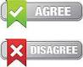
When we can, we will ask you if this is ok first, you can say yes or no. If we have to tell someone else, we will let you know, so you can stay in control.

There are a few times we will have to tell someone else what you have said.
We sometimes tell our managers, so that they can check we are doing a good job.
We will write information about our meetings on our computers or in a file.
You can see this information at any time.

Only people we work with us will see this information.
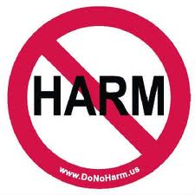
We will also have to tell someone if we are worried that someone is being hurt or might be hurt. If this happens then we will talk to you about it first, and help you to stay in control.
If you have any questions or would like support, you can ring us on: 07747 770322 or 01484 540551
Or Email: info@jigsaw-training.org.

Date: April 2014 Reviewed: June 2015

